FBR2 -

Functionality
This function allows you to post a new accounting document using a previously posted FI document as a reference. You can use this option to speed up data entry.

Scenario
You post frequently similar GL documents: the amounts are different, but GL accounts are the same. You want to use one of the previously entered documents as a reference.

Requirements
Previously posted GL document or sample document.

Menu Path | Accounting → Financial Accounting → General Ledger → Document Entry → FB50 - Enter G/L Account Document
Transaction Code | FBR2

1. Double click on FB50 - Enter G/L Account Document

Enter G/L account document: Company code 5200

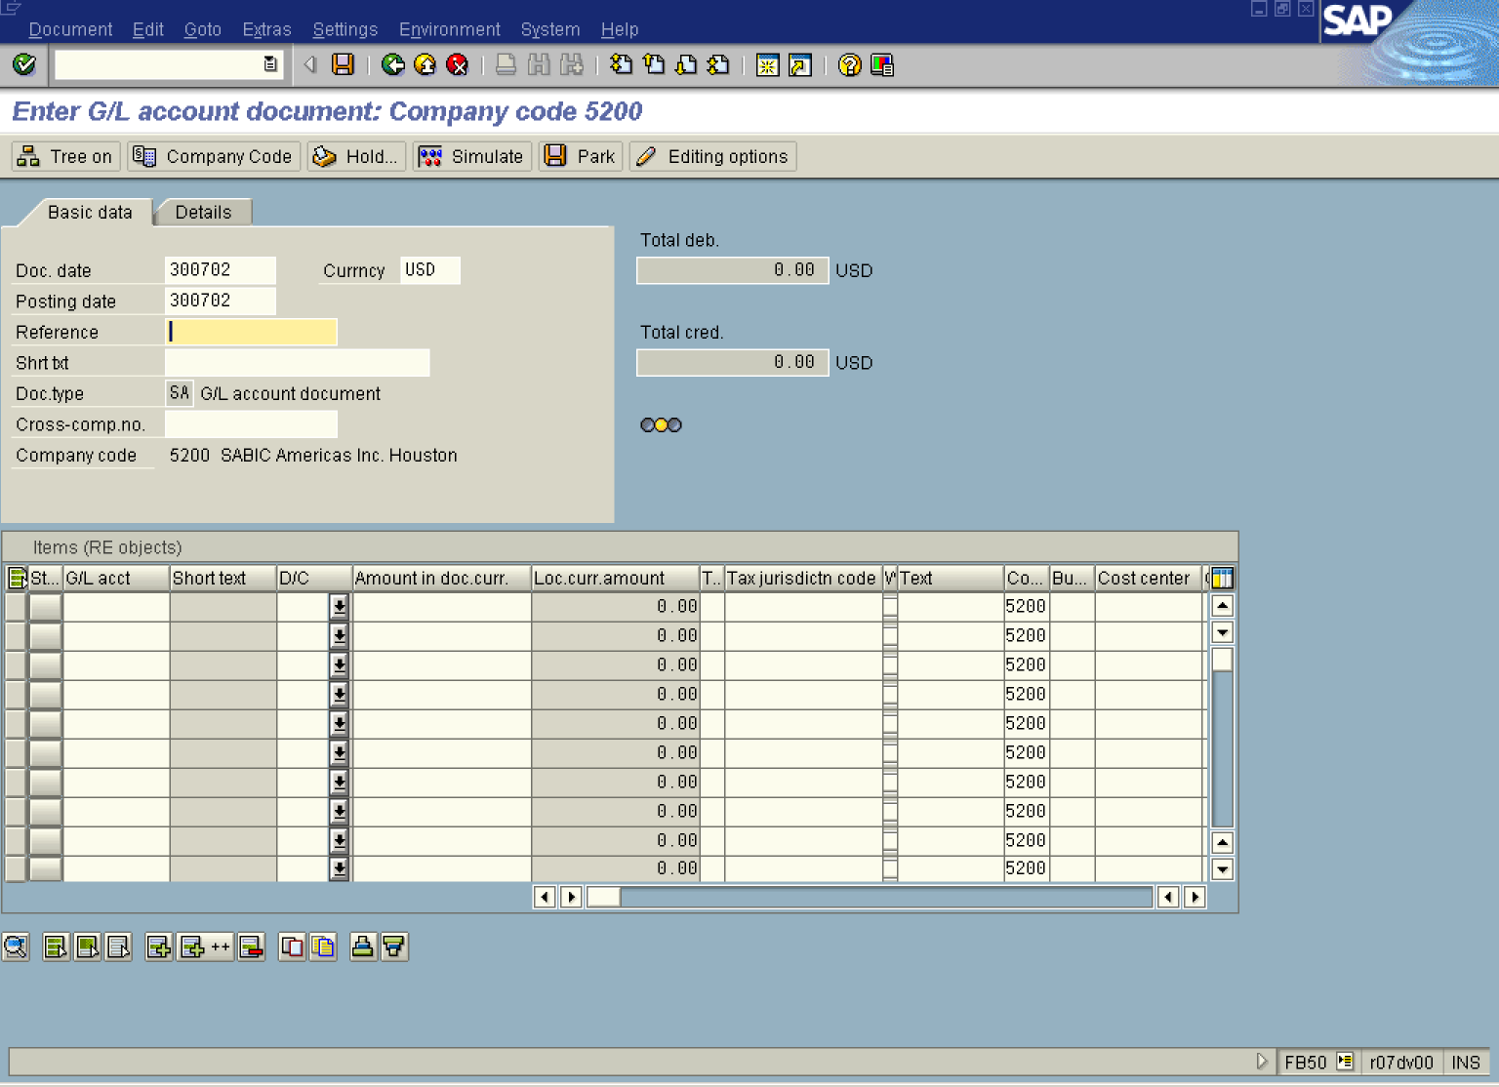

2. Update the following fields:

Field Name | Field Description | Values
Doc. date | Document date | Example: 300702
Currncy | Posting currency | Example: USD
Posting date | Date that the business transaction occurred | Example: 300702

3. Select from the menu path: Goto -> Post with Reference.

Post Document: Header Data

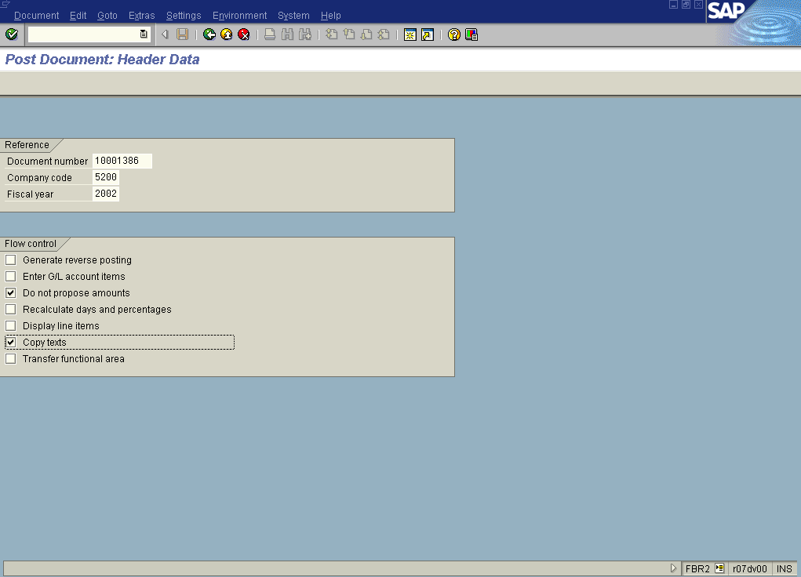

4. Update the following fields:

Field Name | Field Description | Values
Document number | This is the document number you want to use as a reference | Example: 10001386
Company code | Code identifying a separate legal entity for which a separate set of accounts is maintained for external reporting purposes | Example: 5200
Fiscal year | Fiscal year number | Example: 2002

5. Click Do not propose amounts

6. Click Copy texts .

7. Click Enter Button to confirm your entries.

Post Document: Header Data

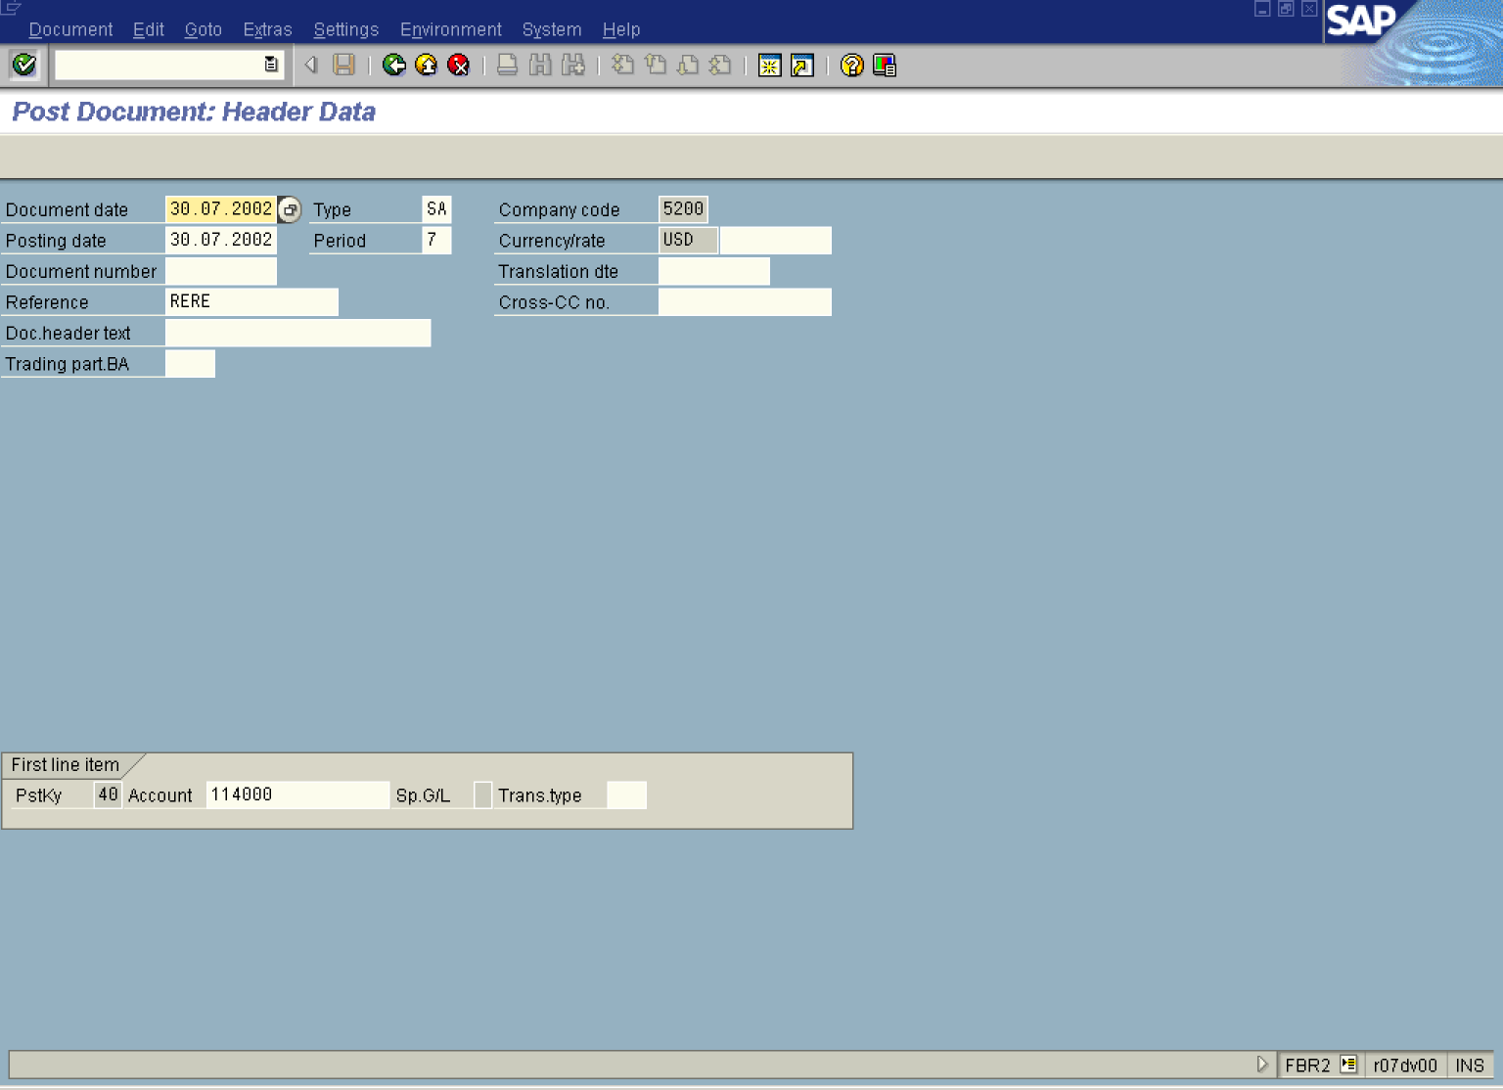

8. Click Enter Button to confirm your entries.

Post Document: Header Data

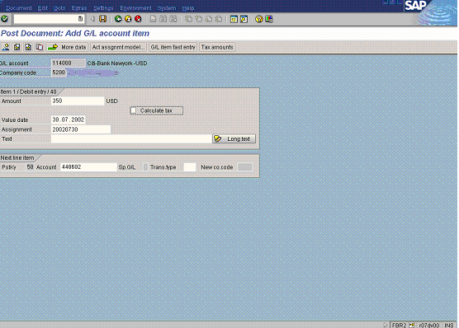

9. Update the following fields:

Field Name | Field Description | Values
Amount | Amount of the first line item | Example: 350

10. Click Enter Button to confirm your entries.

Post Document: Add G/L account item

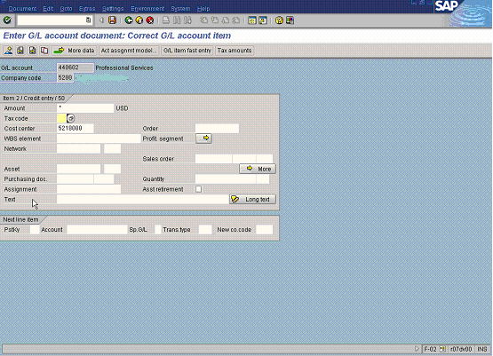

11. Update the following fields:

Field Name | Field Description | Values
Amount | Amount of the second line item | Example: *

12. Click Enter Button to confirm your entries. The system will display a document overview:

Post Document: Display Overview

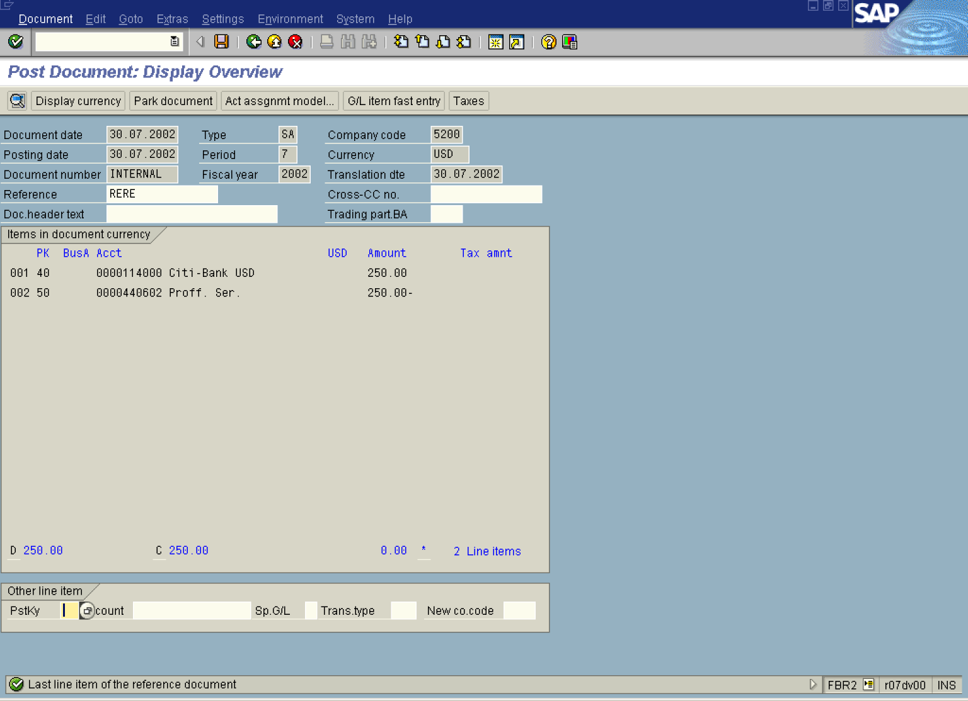

13. You can now save the document or park it. Click Save Button .

14. The message bar displays “Document XXXXXX 5200 was posted”.

